NAME :- Nikhil Sunil Wankhede

ROLL NO :-198

PRACTICAL NO :-12

Title:- practical based on implementing use of trigger

--------------------------------------------------------------------------------------------------------

Create table student2 (

s_id int PRIMARY KEY IDENTITY,

name varchar(50),

computer int,

java int,

DBMS int,

total int,

perc float

);

insert into dbo.student2 (name,computer,java,DBMS) values ('anjali', 60,70,80);

insert into dbo.student2 (name,computer,java,DBMS) values ('shital', 40,60,50);

insert into dbo.student2 (name,computer,java,DBMS) values ('vaishnavi', 90,70,60);

insert into dbo.student2 (name,computer,java,DBMS) values ('akansha', 55,75,69);

insert into dbo.student2 (name,computer,java,DBMS) values ('vrushali', 70,75,85);

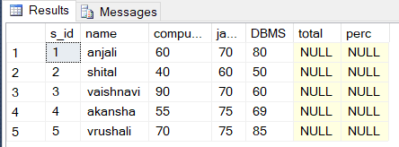

insert into dbo.student2 (name,computer,java,DBMS) values ('anjali', 60,70,80);

insert into dbo.student2 (name,computer,java,DBMS) values ('shital', 40,60,50);

insert into dbo.student2 (name,computer,java,DBMS) values ('vaishnavi', 90,70,60);

insert into dbo.student2 (name,computer,java,DBMS) values ('akansha', 55,75,69);

insert into dbo.student2 (name,computer,java,DBMS) values ('vrushali', 70,75,85);

CREATE trigger dbo.stud_marks

ON student2

FOR INSERT

AS

DECLARE @Id int;

DECLARE @studName varchar(50);

DECLARE @s1 int;

DECLARE @s2 int;

DECLARE @s3 int;

DECLARE @total INT

DECLARE @perc INT

SELECT @Id = @@IDENTITY from inserted;

SELECT @s1 = computer from inserted;

SELECT @s2 = java from inserted;

SELECT @s3 = DBMS from inserted;

SELECT @studName = name from inserted;

SET @total = @s1 + @s2 + @s3;

SET @perc = @total * 100/300;

UPDATE student SET total = @total, perc = @perc

WHERE sid=@Id;